Drain-Based Irrigation Scheduling with Offline Reinforcement Learning in Protected Strawberry Cultivation
Nils Böhringer, Pascal Graf, Nicolaj C. Stache
Drainage feedback is a practical control signal for substrate-grown strawberries, yet deriving irrigation timing from a drainage target is a sequential decision problem. We present a simulation-anchored offline reinforcement learning (offline RL) approach for protected cultivation in Germany. A FAO56-based evapotranspiration-drainage model was calibrated using 107 days of 1-minute tunnel data (481 irrigations) and combined with ten regional weather stations to generate multi-year synthetic episodes. Offline RL agents (BCQ, IQL, PLAS) learned a continuous policy predicting time-to-next irrigation and were evaluated for irrigation-interval versus full-day episode segmentation against a 20% drainage target. Interval‑based episodes yielded the best simulated timing performance, with PLAS achieving 80.3% of decisions within ±20 minutes.

Keywords
protected horticulture, strawberries, drainage, evapotranspiration, offline reinforcement learning, irrigation scheduling
Protected strawberry production has become a central pillar of Germany’s fruit sector. Although strawberries are the country’s second most important fruit after apples, an increasing share of the production area is now grown under protected cultivation. This share exceeded 15% and helps reduce weather-related risks while increasing productivity. In 2024, protected cultivation accounted for a substantial fraction of national harvests and has expanded markedly compared to a decade ago (Bundesinformationszentrum Landwirtschaft 2025). At the same time, climate change is amplifying the challenges of irrigation. Rising temperatures, prolonged dry spells and altered rainfall patterns are increasing the overall demand for water and introducing stronger and less predictable fluctuations in daily water requirements. For sensitive crops such as strawberries, this increases the need for responsive irrigation to safeguard both yield and fruit quality (ALFFA 2024).
As a result, in substrate-based strawberry production, drainage (the volume and composition of the leachate after irrigation) has emerged as a high‑value, high‑resolution control signal for adaptive irrigation. Drainage aligns management directly with agronomic goals because it reflects actual plant water uptake, substrate saturation, and nutrient‑circulation efficiency (Kubota 2019). Drainage-based targets have also proven useful in practice, as higher drainage rate targets are associated with a corresponding increase in water application. Studies indicate that a 20% drainage rate supports improved vegetative growth and the highest proportion of large fruits, emerging as an appropriate operational target (Su-Hyun Choi 2022). However, converting environmental data from multiple sensors into optimal control decisions is an inherently sequential and uncertain problem: actions (irrigation events) influence future states across multiple timescales, and decision quality depends on learning from variable and sometimes sparse feedback (Hutchinson 2025).
Reinforcement Learning (RL) offers a principled framework to learn such sequential irrigation policies directly from data and to adapt them to operational constraints, including water scarcity (Yuji Saikai 2023, Xianzhong Ding 2024). Crucially for commercial production, Offline RL can learn effective policies purely from historical operation data, avoiding risky online exploration while still capturing how climate conditions, drainage responses, and irrigation actions interact over time. This enables data‑driven policies that support plant health, stabilize substrate moisture, and reduce water and fertilizer inputs (T.D. Kelly 2024, Zhao 2023).
The work reported here addresses these gaps through a pragmatic, simulation-anchored offline RL framework targeted at drainage-based scheduling for protected strawberry cultivation in Germany. Specifically, the study (i) calibrates an evapotranspiration-drainage response model for strawberries using an initial season of measured sensor data and subsequently uses public weather station data to generate extended drainage sequences; (ii) constructs and trains offline RL agents on the augmented dataset to learn irrigation timing policies; (iii) explores two distinct episode segmentation strategies, daily episodes versus interval episodes, to evaluate how episode design affects learning and offline policy evaluation.

Materials and Methods

Field Site
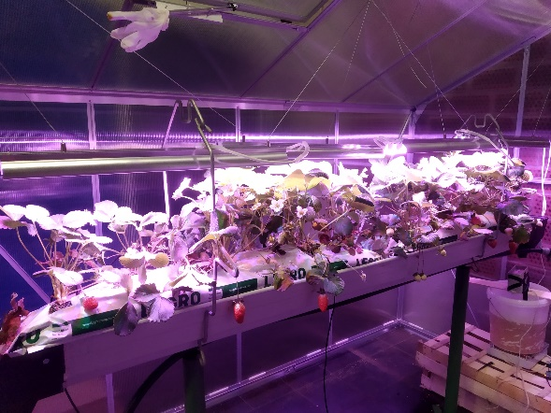
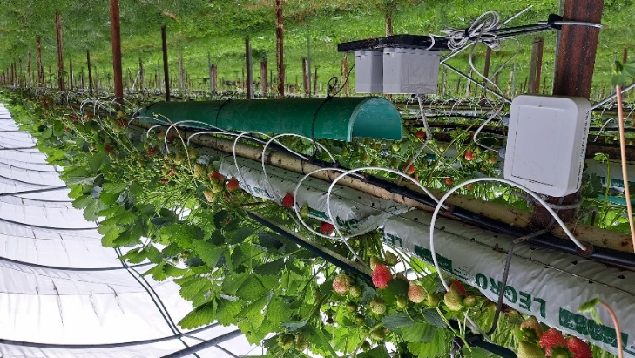
An initial trial in an indoor greenhouse (Figure 1, right) was excluded from further analysis because environmental and irrigation signals exhibited minimal variability and were therefore unsuitable for model development. Subsequent field data were collected during the cropping season 2023 on a commercial strawberry (Fragaria × ananassa) farm in the Lake Constance region, Germany (47°47' North, 9°30' East, altitude 596m above mean sea level). Over the last 10 years, mean annual rainfall was 899.1 mm and the average annual mean, maximum and minimum temperatures were 9.8°C, 34.8°C and -11.8°C, respectively. Monitoring was conducted from 16 May to 14 September including minor interruptions of no more than one week due to work on the plants or damage to the measuring station. The measurement station consisted of a 2 m measurement cell (Figure 1, left). The cell consisted of two 1 m plant sleeves (substrate mix: 60% coconut fibre, 25% peat and 15% perlite), each containing six plants (Frigo A+, everbearing cultivar Murano) and irrigated by four individual drippers per sleeve. The plants were managed in the same manner as the surrounding crop by the farm staff. This management included two runner-pruning events with the objective of stimulating renewed vegetative growth. The farm’s irrigation schedule begins at 9:00 a.m. and each irrigation cycle has a predetermined duration of 4 minutes. Subsequent irrigations were automatically triggered by a timer/radiation-based irrigation control system. These irrigations were subject to continuous supervision and adjustment by staff, who conducted manual checks to maintain optimal plant hydration levels.
Figure 1: Lake Constance measuring station (left), greenhouse test station (right)

Instrumentation and Data Collection
A self‑developed measuring station (Figure 1, left) recorded air temperature, relative humidity, the volume of applied irrigation water (drip) and the drainage volume (drain) directly at the measurement station. Drip and drain volumes were measured using tipping‑bucket rain gauges calibrated to 2 ml per tip. To monitor water volumes, one representative dripper was used for drip measurements, whereas the combined drainage from the full 2 m section, irrigated by eight drippers, was collected and recorded. In addition to the station inside the tunnel, an outdoor sensor (SenseCAP S2102) recorded incoming radiation adjacent to the site.
All variables were logged at a resolution of 1 min. The resulting dataset comprised 107 fully monitored days and 481 irrigation cycles and served as the foundation for developing the subsequent drainage model.

Estimation of drainage-based on crop evapotranspiration:
Drainage was calculated under the assumption that any irrigation water not consumed by evapotranspiration contributes directly to drainage. Accordingly, drainage $drain$ was derived as the difference between irrigation input $drip$ and crop evapotranspiration $ET_{c}$:
$$drain=drip-ET_{c}$$ | (Eq. 1)
Here, $ET_{c}$ represents crop evapotranspiration, defined as the combined water loss from substrate evaporation and plant transpiration. $ET_{c}$ was calculated following the widely recognized FAO56 methodology for determining crop water requirements (Richard G. Allen 1998):
$${ET}_{c}=ET_{0 tunnel}∙K_{c}$$ | (Eq. 2)
where $ET_{0 tunnel}$ is the reference evapotranspiration inside the plastic tunnel and $K_{c}$ is the crop coefficient specific to strawberries. Because solar radiation and wind speed are significantly reduced inside plastic-covered tunnels, the resulting $ET_{0 tunnel}$ values are known to be lower than standard outdoor reference $ET_{0}$ (Pedro Gavilán 2015). To account for this, $ET_{0 tunnel}$ was estimated using the method proposed by (M. D. Fernández 2010), which provides empirical equations based solely on the day of year (DOY) and the internal solar radiation $R_{s tunnel}$:
DOY < 220: $ET_{0 tunnel}=\left(0.288+0.0019∙DOY\right)∙R_{s tunnel}$ | (Eq. 3)
DOY > 220: $ET_{0 tunnel}=\left(1.339-0.00288∙DOY\right)∙R_{s tunnel}$ | (Eq. 4)
Despite being derived for Mediterranean climates, the deviation from local conditions is expected to be compensated by the later calibration of the model using sensor data. The required internal solar radiation $R_{s tunnel}$ was estimated from measured outdoor solar radiation $R_{s}$ and the transmissivity of the plastic cover:
$$R_{s tunnel}=R_{s}∙$$ | (Eq. 5)
depends on the tunnel covering material, its age, and its cleanliness. Therefore, a practical value of = 0.75, reported by Lozano et al. (David Lozano 2016), was used as it reflects typical conditions of the polytunnels on the farm.
The crop coefficient $K_{c}$ defined in (Eq. 2) adjusts reference evapotranspiration to the crop specific conditions. Published $K_{c}$ values for strawberries in southern Germany are in the range [0.6, 0.9] (Martin Müller 2020), but these refer exclusively to open-field cultivation. In tunnel-grown everbearing strawberries, additional factors significantly alter water use, including the two runner-pruning events mentioned earlier, which substantially reduce transpiration. Furthermore, $ET_{c}$ calculations are typically referenced to 1 m² of ground area, whereas our measurement cell consists of a strawberry row in substrate bags with a non-representative area. To account for these sources of uncertainty, all effects were incorporated into the $K_{c}$ parameter, which was defined as a time-dependent factor that varied on a weekly basis and was calibrated using the collected data.
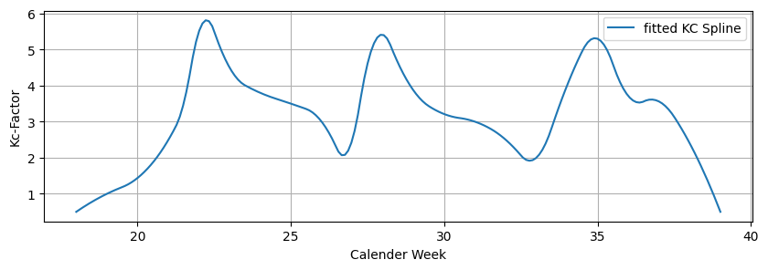
Figure 2: Weekly $K_{c}$ factor calibrated using the collected data

Synthetic drainage generation
To generate the training datasets, meteorological data from the past five years have been used. These data were collected from ten public weather stations (Landwirtschaftliches Technologiezentrum Augustenberg 2026). The selected stations were located near the study site and provided measurements of air temperature, relative humidity, and solar radiation at a resolution of 10 minutes. Only data from calendar weeks 18 to 39 were included, as irrigation decisions are made exclusively during this period. Synthetic drainage was calculated using solar radiation data from the weather stations in combination with the assumptions defined in (Eq. 1). The irrigation volume per event was fixed due to a constant irrigation duration of 4 minutes and validated through sensor data analysis, resulting in an average applied volume of 5 L per irrigation event. To introduce realistic variability into the training data, a target drainage value was randomly sampled within an allowable deviation range. An ideal drain‑to‑drip ratio of 20% (corresponding to 1 L per irrigation event) was adopted as the target value, consistent with experimental findings (Su-Hyun Choi 2022). A maximum deviation of 150% relative to this ideal value was allowed in the datasets resulting in a theoretical range of [-0.5, 2.5] L. The randomly selected value within this range defines the target drainage ${drain}_{target}$, for a given irrigation interval. For each interval, the model iterates forward from the last irrigation event, accumulating evapotranspiration $ET_{c, cumulativ}$ initialized at zero. The interval progresses until the following condition is met according to (Eq. 1):
$${ET_{c, cumulativ}≥drip-drain}_{target}$$ | (Eq. 6)
At this point, the interval is terminated. This time point represents the moment at which a subsequent irrigation event would produce exactly the selected ${drain}_{target}$. This procedure ensures internal consistency, as every generated drainage value remains physically linked to the evapotranspiration dynamics of the respective episode. Because ${drain}_{target}$ is a scalar value whereas the model inputs require a time series, empirical drainage profiles derived from measurements were imposed. These profiles assume that 70% of the total drainage occurs 10 minutes after irrigation (first sample), 90% after 20 minutes (second sample), and 100% at all subsequent timesteps.

Offline Reinforcement Learning
Offline RL, also known as batch RL, is a learning paradigm in which an agent is trained using a fixed, previously recorded dataset. During the learning process, the agent is not permitted to interact with the real or simulated environment. This differs fundamentally from classical reinforcement learning, in which an agent actively explores the environment to gradually learn an optimal policy. It aims to derive policies that improve over the behavior policy underlying the original system while avoiding unsafe extrapolation beyond the data distribution. A key technical difficulty is that offline RL must estimate policies for states and actions that may not be adequately represented in the dataset. Formally, this dataset consists of transition tuples (Sergey Levine 2020):
$$D=\{\left(s_{i},a_{i},s_{i}^{'},r_{i}\right)\}$$ | (Eq. 7)
where $s_{i}$is the current state, $a_{i}$ the applied action, $r_{i}$​ the reward, and $s_{i}'$ the next state. This setting avoids risky online exploration and leverages historical operational data for policy learning.
The state $s$ is designed to capture the relevant environmental and system conditions at a given decision time, while remaining low‑dimensional enough to allow efficient learning. We define the state vector as:
$$s=\{d,t_{abs},t_{irri},T,H,R,D\}$$ | (Eq. 8)
with $d$ denoting the day of the year, $t_{abs}$ the absolute time of day, $t_{irri}$ the time since the most recent irrigation, and $T$, $H$, $R, D$representing cumulative temperature, relative humidity, solar radiation, and drainage, respectively. This state therefore reflects both the seasonal and daily context, alongside cumulative atmospheric demand and the system’s hydrologic response.
The action $a$denotes the set of admissible decisions available to the agent in each state. The action space is continuous and parametrized as the predicted time until the next irrigation event. For each transition, the model outputs a real-valued scalar indicating how many minutes remain until the next irrigation should occur.
$$a​∈R$$ | (Eq. 9)
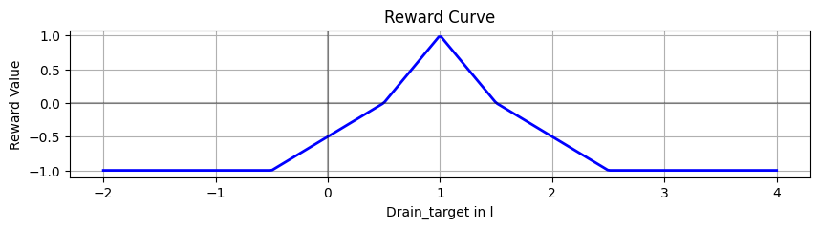
The reward $r$ is defined as the function $r\left(drain_{traget}\right)$, and assigns a scalar reward for each irrigation interval based on a given $drain_{traget}$. As illustrated in Figure 3, a piecewise-linear, clipped reward is used. The reward is positive within the tolerance band [0.5, 1.5] L, corresponding to ±10% of the applied irrigation volume of 5 L and reaches its maximum at $drain_{traget}=1 L$ which represents the desired drainage ratio of 20%. Outside this interval, the reward becomes negative and decreases linearly until it is clipped at -1.
Figure 3: Reward curve $r(drain_{target})$
Prior to training, both the scalar action $a$ and state $s$ variables were linearly normalized using min-max preprocessing, ensuring that all state variables and actions were scaled to the interval [-1, 1]. For training, two different episode-construction strategies were evaluated.
- The first approach followed an irrigation-interval-based episode structure in which all cumulative environmental variables $(T, H, R, D)$ were reset at each irrigation event to capture only the short-term atmospheric demand and system response. The final episode of the dataset was excluded, as it never terminated naturally and was found to negatively impact training stability.
- The second approach instead used a full-day-based episode structure starting at 09:00 AM (from the first irrigation) and continuing until midnight, without resetting cumulative variables. Each episode therefore had a fixed length determined by the predefined start and endpoint and sampling frequency.
For training, only the model-generated dataset was used, while the recorded measurements were reserved exclusively for evaluation to ensure a clean separation between training and assessment. To conduct the training, the open-source offline RL library d3rlpy (Imai 2022) was employed. This library provides a broad set of state-of-the-art algorithms and a user-friendly interface. To ensure a rigorous and unbiased algorithm selection, an initial benchmark was conducted across all algorithms available in d3rlpy using default hyperparameters. The three best-performing algorithms were then selected based on the action-difference metric between dataset actions and agent-generated actions. For both approaches the top performers were Policy in Latent Action Space (PLAS) (Held 2020), Batch-Constrained Q-learning (BCQ) (Precup 2019), and Implicit Q-learning (IQL) (I. K. Levine 2021).

Results

Drainage Model
The evapotranspiration-driven drainage model was evaluated by comparing daily calculated evaporation values against measured daily evaporation inferred from the on-site irrigation drainage balance. The comparison is shown in Figure 4, where each marker represents one day of the monitoring campaign and is complemented by an ideal reference line and a linear regression fit. Overall, the point cloud indicates a clear positive association between calculated and measured values, while also revealing a substantial spread around the ideal line, suggesting remaining model and measurement uncertainties at the daily aggregation level. This observation is further supported by the model metrics reported in Table 1.
Table 1: Coefficient of determination (R²), root mean square error (RMSE), relative error (RE), mean absolute error (MAE) and mean bias error (MBE) from the comparison between calculated and measured evaporation values.
R² | RMSE in L day⁻¹ | RE in % | MAE in L day⁻¹ | MBE in L day⁻¹
0.69 | 13.21 | 36.8 | 9.79 | 4.15

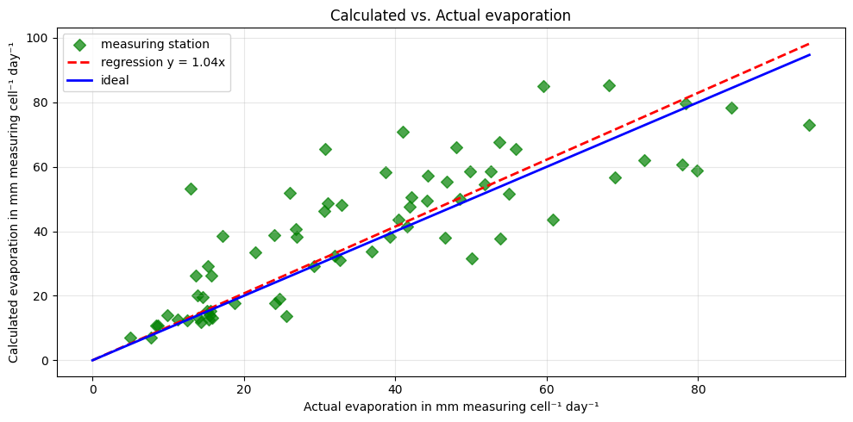
Figure 4: Comparison between calculated and measured evaporation values. Each point corresponds to a daily evaporation value. The figure also shows the 1:1 line and a linear regression line.

Training Results
Figure 5 illustrates representative irrigation episodes by plotting the predicted actions of the three learned policies and two episode structures against the ideal schedule. Because the environment and dataset are available at a discrete sampling rate of 10 minutes, policy outputs were translated into a discrete irrigation decision using a 10‑minute execution threshold. Whenever a policy predicted a remaining time-to-irrigation of less than 10 minutes, the subsequent sample was treated as the executed irrigation event. This discretized irrigation timestamp was then used as the predicted irrigation time for further evaluations.
The qualitative behavior of the representative irrigation episodes in Figure 5 already highlights clear differences between algorithms and episode designs. Notably, even in the irrigation-interval setting (Figure 5a), all trajectories deviate visibly from the ideal decline, reflecting the substantial episode-to-episode variability observed across the dataset and cautions against over-interpreting single examples. These deviations become even more pronounced in the full-day formulation (Figure 5b), where non-resetting cumulative variables and early prediction errors can compound over the day, pushing subsequent states further away from the local decision context. Therefore, Figure 5 primarily serves as a qualitative illustration of typical behaviors under each episode design.
To quantify the prediction accuracy of each algorithm under both episode constructions, performance was assessed using the timing offset between the predicted and the ideal irrigation event for every episode. Negative values indicate earlier irrigation than the reference schedule and positive values indicate later irrigation. These results were then visually represented using a violin plot overlaid on a box plot in Figure 6. In addition, the analysis reports the fraction of episodes for which a policy did not trigger any irrigation within a tolerance window of ±90 min (reported as ‘Errors’ in Table 2), which captures failure cases caused by overly conservative actions or predictions that never cross the execution threshold.

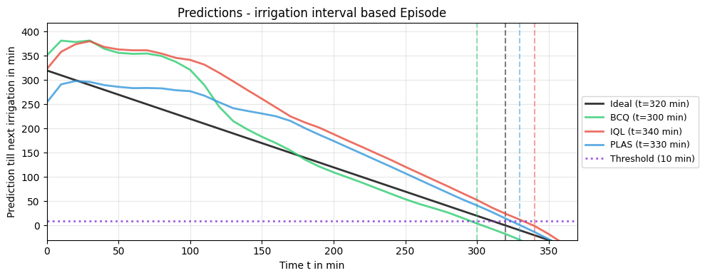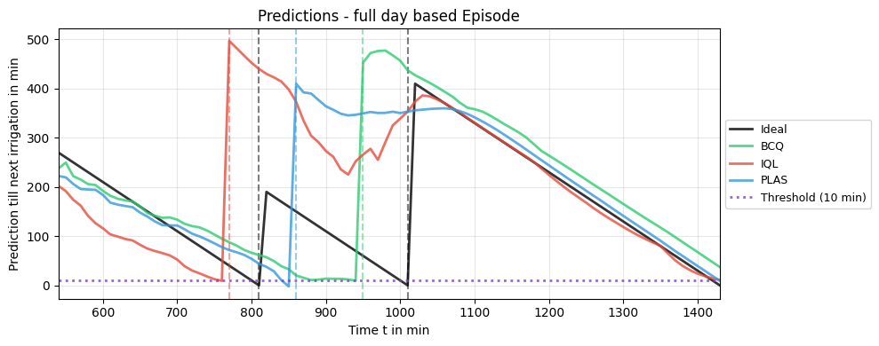
b)
a)
Figure 5: Example episodes showing the predicted action over time for three offline RL policies (BCQ, IQL, PLAS) compared to the ideal irrigation schedule. a) irrigation-interval-based episodes and b) full-day-based episodes. The solid black curve indicates the ideal action and the colored curves correspond to the respective policy predictions. The vertical dashed lines indicate when each policy would irrigate. Note that these are single-episode examples and deviations from the ideal curve can vary substantially across episodes.
Considering the quantitative results on the training dataset (Table 2 top, sim and Figure 6a, left column), the irrigation-interval structure shows that PLAS achieves the best timing accuracy (±10 min: 58.59%, ±20 min: 80.30%, ±30 min: 89.61%). At the same time, it yields very few failures (1.17%) and the tightest standard deviation (StdDev) of 19.85 min. IQL performs comparably, reaching 51.24% / 73.88% / 84.91% within the same tolerance windows, with a 1.70% failure rate (StdDev: 24.73 min). In contrast, BCQ trails substantially (11.29% / 24.31% / 40.91%) and exhibits a much wider dispersion (StdDev: 43.07 min), aligning with the more erratic trajectories observed in Figure 5a.
When the trained policies were transferred (Table 2 top, meas and Figure 6a, right column), performance deteriorated markedly for all policies, revealing a pronounced model-to-real gap. For irrigation-interval episodes, the proportion of failures (outside ±90 min) increased to 37.27-46.14%, and the share of predictions within operationally relevant tolerances dropped to 30.68-37.27% (±20 min) and 40.68-42.95% (±30 min). The offset distributions also widen considerably, indicating reduced confidence and higher episode-to-episode variability. BCQ showed a tendency towards earlier irrigation on average (mean −9.96 min), whereas IQL and PLAS remained closer to unbiased timing (means of +4.22 min and +0.17 min, respectively) but still with sizeable spreads (StdDev 28.53-31.11 min).

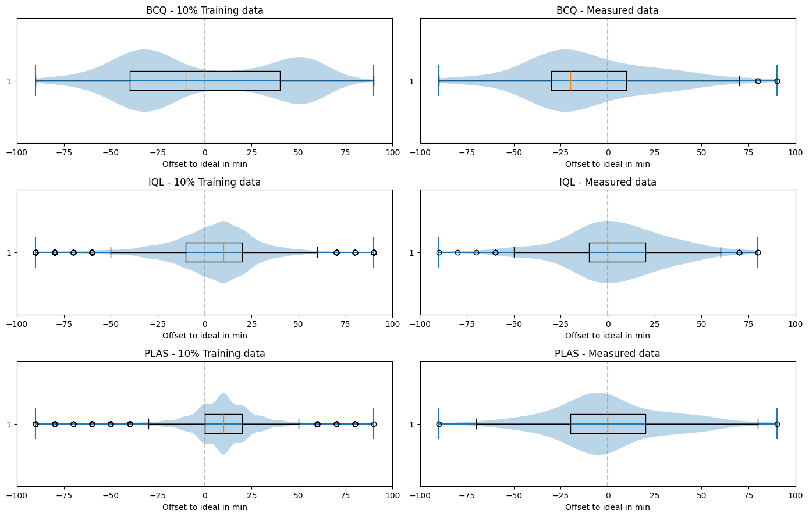
a)
b)
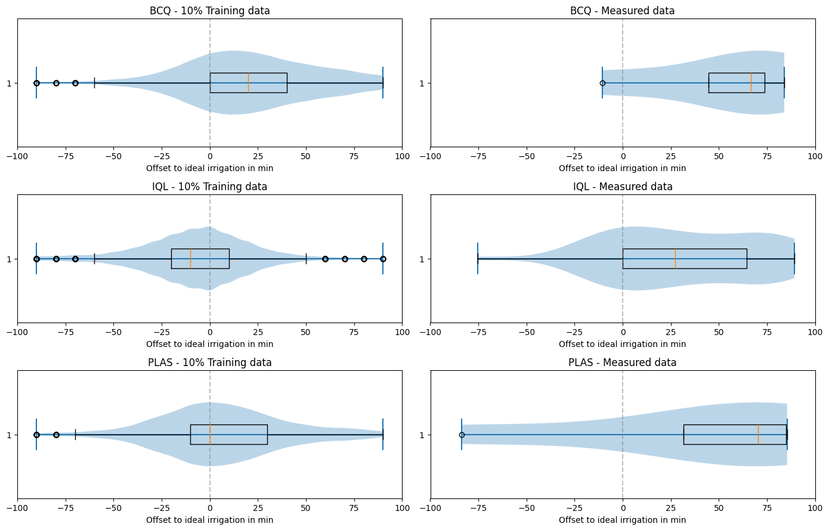
Figure 6: Distributions of the offset to the ideal schedule (minutes) for three methods (BCQ, IQL, PLAS) under simulated (left column) and measured (right column) conditions (excluding predictions outside ±90 min). a) irrigation-interval-based episodes and b) full-day-based episodes. Each panel shows a violin density with an overlaid box (median and interquartile range) and individual outliers (circles). The vertical dashed line marks 0 min (no offset).
Table 2: Evaluation results of the trained models on training data (sim) and real measurement data (meas). Errors refers to the proportion of episodes in which the model did not identify an irrigation time within ±90 min. The columns labelled ±10/20/30 min indicate the percentage of episodes in which the time deviation between the predicted and ideal irrigation times is within the respective tolerance range. The statistical indicators mean and standard deviation (StdDev) describe the distribution of the time deviation in minutes.
Model | Number of Episodes | Errors (>±90min) in % | Within ±10 min  in % | Within ±20 min  in % | Within ±30 min  in % | Mean Offset  in min | StdDev  in min

Irrigation interval-based episodes:
BCQ - sim | 3580 | 6.06 | 11.29 | 24.31 | 40.91 | -1.68 | 43.07
IQL - sim | 3580 | 1.7 | 51.24 | 73.88 | 84.91 | 3.93 | 24.73
PLAS - sim | 3580 | 1.17 | 58.59 | 80.3 | 89.61 | 8.58 | 19.85
BCQ - meas | 481 | 37.27 | 15.45 | 30.68 | 41.59 | -9.96 | 34.7
IQL - meas | 481 | 44.55 | 26.36 | 37.27 | 42.95 | 4.22 | 28.53
PLAS - meas | 481 | 46.14 | 25.0 | 33.18 | 40.68 | 0.17 | 31.11
Full-day-based episodes:
BCQ - sim | 1142 | 41.08 | 18.97 | 29.13 | 37.11 | 20.79 | 33.81
IQL - sim | 1142 | 12.92 | 39.32 | 57.85 | 69.29 | -7.2 | 28.93
PLAS - sim | 1142 | 47.31 | 20.49 | 30.82 | 38.53 | 6.2 | 33.55
BCQ - meas | 107 | 89.91 | 1.1 | 3.29 | 4.82 | 30.66 | 38.53
IQL - meas | 107 | 98.9 | 0.0 | 0.0 | 0.0 | 37.64 | 63.85
PLAS - meas | 107 | 99.12 | 0.0 | 0.22 | 0.22 | 51.69 | 36.67

Considering the full-day-based episode approach (Table 2 bottom, sim and Figure 6b, left column), the timing-offset distributions were substantially worse than those observed under the irrigation-interval-based approach. The results indicate that BCQ and PLAS frequently failed to produce a valid irrigation decision within the ±90 min evaluation window, with high failure rates of 41.08% and 47.31%, respectively, and correspondingly low timing accuracy. IQL remains the best-performing method under this episode design, but it still exhibited 12.92% failures and achieves only 57.85% predictions within ±20 minutes of the ideal schedule. When moving to measured conditions (Table 2 bottom, meas and Figure 6b, right column), performance degraded even further, effectively resulting in a total breakdown of the full-day approach. All three algorithms showed extremely high error rates between 89.91% and 99.12%, meaning that for most days no irrigation time was identified within ±90 minutes. Consistently, the models virtually never predict irrigation within ±30 minutes of the ideal reference under real measurements.
Overall, the irrigation-interval episode approach enables strong learning performance with PLAS and IQL achieving high timing accuracy and low error rates. However, evaluation on measured episodes revealed a pronounced model-to-real gap characterized by a systematic earlier-irrigation bias across all algorithms. The full-day episode approach proved considerably less effective. Even on training data the algorithms showed high failure rates. On measured full-day episodes, all three methods fail completely. This indicates that learning a stable policy over long, non-resetting horizons is substantially harder with the current state representation and dataset, and that the interval-based segmentation is the more appropriate design for drainage-targeted scheduling with the available data.

Discussion

Interpreting the evapotranspiration - drainage model
The drainage model achieved a coefficient of determination of $R^{2}=0.69$ for daily evapotranspiration estimates, indicating that radiation-driven $ET$ captures a substantial portion of day-to-day water demand but leaves meaningful unexplained variance. This is likely because the model compresses multiple uncertainties into a time-varying weekly crop coefficient ($K_{C}$), including plant development, runner-pruning events, and the mismatch between ground-area-based $ET_{C}$ and the effective area of the substrate bags. While this consolidation is pragmatic, it also means that $K_{C}$ absorbs phenomena that may change abruptly (e.g., runner pruning), which a weekly schedule may only approximate. In addition, the tunnel microclimate differs from that of nearby weather stations and even from measurements taken at a single point inside the tunnel, spatial gradients in radiation, humidity, and temperature can be substantial in protected horticulture. Despite these limitations, the model appears sufficiently informative to learn policies in-distribution, as evidenced by the strong results on simulated episodes. Importantly, the observed bias and spread are consistent with a model capturing the overall trend but remains far from being a perfect model.

Offline RL performance: algorithms and episode design
On simulated data, the irrigation-interval episode design clearly outperformed the full-day design. Resetting cumulative variables at each irrigation event likely simplifies the learning problem by focusing the state on the local decision context (recent atmospheric demand and recent drainage response) instead of requiring the agent to integrate long-horizon dynamics over an entire day. With the current state representation, the full-day formulation appeared less informative, which may be because cumulative variables grow monotonically and can blur the distinction between different intra-day cycles, increasing the difficulty of function approximation for value learning.
The discretization of continuous action into a 10-minute execution threshold is a practical choice given the 10-minute sampling interval used in the synthetic environment. However, it introduced an additional source of evaluation noise: two policies that differ only slightly around the threshold can trigger at different timesteps. Future implementations could instead formulate the action directly as a discrete decision at each timestep (irrigate now vs. wait) or increase temporal resolution where sensor and actuation hardware allow.

Understanding the model-to-real gap
Policies that are highly accurate on simulated intervals deteriorate sharply on measured episodes, with a large fraction of intervals receiving no valid irrigation decision within ±90 minutes. This gap likely arises from a combination of the already mentioned model mismatch, reward mismatch, and distribution shift in the state-action coverage. Reward mismatch arises because the ideal schedule in the training dataset is defined by a criterion that exactly achieves the sampled drainage target, whereas real farm scheduling is timer- and radiation-controlled and periodically adjusted by staff. Therefore, the measured actions may reflect operational heuristics, equipment constraints, and risk aversion rather than strict drainage-optimality. When a policy is trained to imitate synthetic optimal timing but evaluated against real episodes, or vice versa, apparent performance can degrade even if the policy is agronomically reasonable. The coverage shift is also present because offline RL depends critically on whether the evaluation states lie within the support of the training dataset. Even with min-max normalization, measured episodes may present combinations that are rare or absent in synthetic data, especially around atypical weather patterns, irrigation disruptions, or post-pruning recovery. Under such shift, Q-function extrapolation becomes unreliable and conservative algorithms may default to wait, producing the observed failure modes.
The failure of the full-day approach under measured conditions further suggests that long-term policies are particularly sensitive to mismatch. Errors accumulate across the day because the state is not reset, and any early misprediction pushes subsequent states further out of distribution. This highlights the practical value of designing episodes that align with meaningful, recurrent control cycles - in this case, irrigation intervals.

Implications and recommendations for future work
For deployment-oriented irrigation control, several concrete improvements follow from the results.
• Expand real-world sensing: adding substrate moisture, nutrient content, solution nutrient content and ideally weight-based lysimeter signals would reduce partial observability and allow the agent to condition decisions on the substrate’s actual water status rather than on proxies alone.
• Improve model fidelity and diversity: calibrate transmissivity and microclimate relationships per tunnel and season. Apply domain randomization (e.g., varying $K_{C}$trajectories, irrigation volumes, drainage delay parameters) so that the synthetic dataset spans plausible real dynamics.
• Use safer offline RL and validation: incorporate uncertainty estimation or conservative penalties to reduce extrapolation, complement action-difference metrics with off-policy evaluation estimators, and test policies in shadow mode before allowing actuation.
Overall, the present study demonstrates that offline RL can learn precise interval-level irrigation timing under a well-defined synthetic objective, but it also makes clear that data quantity, state observability, and model calibration are the key determinants of success when transitioning to real protected horticulture systems.

Conclusions
In summary, this paper shows that drainage-targeted irrigation scheduling is a promising application for offline RL, but robust real-world performance requires closing the model-to-real gap.
• A radiation-driven evapotranspiration model calibrated on 107 monitored days provides a workable drainage simulator for synthetic data generation, achieving $R^{2}=0.69$ at the daily scale.
• Offline RL can learn irrigation timing policies that closely match a drainage-target ideal schedule in simulation when episodes are segmented by irrigation intervals. PLAS and IQL are markedly more stable than BCQ under this formulation.
• Full-day episode segmentation performs substantially worse and becomes brittle under measured conditions, indicating that long, non-resetting horizons are challenging with the current low-dimensional state representation.
• A pronounced model-to-real gap persists. Policies trained on synthetic data degrade strongly on measured episodes, highlighting model mismatch and distribution shift as the central barriers to field deployment.
• Future work should prioritize richer in-tunnel sensing, model randomization, and conservative validation workflows (e.g., shadow deployment) to enable safe, drainage-based RL irrigation control.

References
ALFFA, LAWA und BLAG. „Fokus Wasser – Folgen des Klimawandels und Maßnahmen zur Anpassung. Beispiele und Lösungsansätze für Wechselwirkungen zwischen Wasserwirtschaft, Landwirtschaft, Forstwirtschaft, Aquakultur und Binnenfischerei.“ 2024.
Bundesinformationszentrum Landwirtschaft. Immer mehr heimische Erdbeeren wachsen unter Schutzabdeckungen. 28. 04 2025. https://www.landwirtschaft.de/infothek/landwirtschaft-in-zahlen/immer-mehr-heimische-erdbeeren-wachsen-unter-schutzabdeckungen (Zugriff am 30. 01 2026).
David Lozano, Natividad Ruiz, Pedro Gavilán. „Consumptive water use and irrigation performance of strawberries.“ Agricultural Water Management 169, 2016: 44-51.
Held, Wenxuan Zhou and Sujay Bajracharya and David. „PLAS: Latent Action Space for Offline Reinforcement Learning.“ 2020.
Hutchinson, George Kerrigan and Nguyen, Lan Xuan and Rubio Ames, Zilfina and Nemali, Krishna and Ferrarezi, Rhuanito Soranz. „Sensor-controlled fertigation management for higher yield and quality in greenhouse hydroponic strawberries.“ Frontiers in Plant Science, January 2025: Volume 15 - 2024.
Imai, Takuma Seno and Michita. „d3rlpy: An Offline Deep Reinforcement Learning Library.“ Journal of Machine Learning Research 23 (2022): 1-20.
Kubota, C. Fertigation (Controlled Environment Berry Production Information). 2019. https://u.osu.edu/indoorberry/fertigation/ (Zugriff am 31. 01 2026).
Landwirtschaftliches Technologiezentrum Augustenberg. Aktuelle Wetterdaten Baden-Württemberg. 2026. https://www.wetter-bw.de/Agrarmeteorologie-BW/Wetterdaten/Alle-Stationen (Zugriff am 06. 02 2026).
Levine, Aviral Kumar and Aurick Zhou and George Tucker and Sergey. „Conservative Q-Learning for Offline Reinforcement Learning.“ 2020.
Levine, Ilya Kostrikov and Ashvin Nair and Sergey. „Offline Reinforcement Learning with Implicit Q-Learning.“ 2021.
M. D. Fernández, S. Bonachela, F. Orgaz, R. Thompson, J. C. López, M. R. Granados, M. Gallardo & E. Fereres. „Measurement and estimation of plastic greenhouse reference evapotranspiration in a Mediterranean climate.“ Irrigation Science, 2010: Volume 28, pages 497–509.
„Kulturartbezogene Kennzahlen.“ In Fachliche Grundlagen zur Bewässerungs-App, Teil 1, von Jana Zinkernagel, Jürgen Kleber, Ekkehard Fricke, Michael Beck , Markus Göttl Martin Müller. 2020.
Pedro Gavilán, Natividad Ruiz, David Lozano. „Daily forecasting of reference and strawberry crop evapotranspiration in greenhouses in a Mediterranean climate based on solar radiation estimates.“ Agricultural Water Management, 2015: 307-317.
Precup, Scott Fujimoto and David Meger and Doina. „Off-Policy Deep Reinforcement Learning without Exploration.“ 2019.
Richard G. Allen, Luis S. Pereira, Dirk Raes, Martin Smith. „Crop evapotranspiration - Guidelines for computing crop water requirements.“ FAO Irrigation and drainage paper 56, 1998.
Sergey Levine, Aviral Kumar, George Tucker, Justin Fu. „Offline Reinforcement Learning: Tutorial, Review, and Perspectives on Open Problems.“ 2020.
Su-Hyun Choi, Dae-Young Kim ,Sun Yi Lee, Min-Sun Chang. „Growth and Quality of Strawberry (Fragaria ananassa Dutch. cvs. ‘Kuemsil’) Affected by Nutrient Solution Supplying Control System Using Drainage Rate in Hydroponic Systems.“ Horticulturae, 2022: 1059.
T.D. Kelly, T. Foster, David M. Schultz. „Assessing the value of deep reinforcement learning for irrigation scheduling.“ Smart Agricultural Technology, 2024: Vol. 7 p. 100403.
Xianzhong Ding, Wan Du. „Optimizing Irrigation Efficiency using Deep Reinforcement Learning in the Field.“ ACM Transactions on Sensor Networks, 2024: 20, 4, Article 99.
Yuji Saikai, Allan Peake, Karine Chenu. „Deep reinforcement learning for irrigation scheduling using high-dimensional sensor feedback.“ PLOS Water 2(9): e0000169, 2023.
Zhao, Haoteng and Di, Liping and Guo, Liying and Li, Lin and Zhang, Chen and Yu, Eugene and Li, Hui. „Optimizing Irrigation Scheduling Using Deep Reinforcement Learning.“ 2023 11th International Conference on Agro-Geoinformatics (Agro-Geoinformatics). Wuhan, China, 2023.

Authors
B.Eng. Nils Böhringer is a Master’s student at Heilbronn University of Applied Sciences (HHN) E‑mail: nils.boehringer1@gmail.com
M.Eng. Pascal Graf is a Research Associate at Heilbronn University of Applied Sciences (HHN) and a member of the Center for Machine Learning (ZML). E‑mail: pascal.graf@hs-heilbronn.de.
Prof. Dr.-Ing. Nicolaj C. Stache is Professor for Automotive Measurement Technology and Sensor Systems, Research Professor for Artificial Intelligence. He also serves as Vice‑Dean (Faculty of Engineering), Program Director of Automotive Systems Engineering (ASE) and Director of the Center for Machine Learning (ZML) at Heilbronn University of Applied Sciences (HHN). E‑mail: nicolaj.stache@hs-heilbronn.de

Acknowledgements
We would like to express our gratitude to Jan Böhringer and Tom Jaksch for the opportunity to conduct this study and for the technical support provided during data collection on the strawberry farm. In addition, we would like to thank Helge de Boer of the Agricultural Technology Centre Augustenberg (LTZ) for providing the weather station datasets.

